JDH Pacific — Veeam Backup for Microsoft 365
Monthly Backup Report — 2026-05
M365 tenant: JDHPac.onmicrosoft.com
Report generated: 2026-05-02 13:01
Executive Summary
218 M365 users in this tenant are protected by Veeam Backup for Microsoft 365. Total backup storage in use is 1.99 TB across 1 repository, with 1 active backup job. This report breaks down storage by Microsoft 365 service, lists per-user backup coverage, and projects how storage will grow over the next 12 months.
218  M365 Users | 29  Users w/ OneDrive backed up | 1.99 TB  Backup Storage Used | 1  Backup Jobs (Running)
Backup Posture
Job | Backup Type | Last Run | Status | Enabled | Next Run
JDH-365 | EntireOrganization | 2026-05-02T08:26:19.002382Z | Running | Yes | 2026-05-02T20:05:00Z
Backup repositories:
Repository | Used | Capacity | Free | Path
JDH_O365 | 1.99 TB | 3.00 TB | 1.00 TB | C:\O365 Backups\bkp_JDH365

Storage by M365 Module
Per-module bytes are estimated by attributing the tenant's total used backup storage in proportion to how often each service appeared in restore points over the last 90 days, weighted by industry-default ratios. For exact per-mailbox / per-site sizes, run the VB365 PowerShell module (Get-VBOEntityData).
Module | Estimated Storage | Share of Total | RP coverage (last 90d)
Exchange | 780.80 GB | 38.3% | 610 / 2,123
OneDrive | 455.56 GB | 22.3% | 783 / 2,123
SharePoint | 740.07 GB | 36.3% | 2,120 / 2,123
Teams | 63.07 GB | 3.1% | 542 / 2,123
Per-User Backup Coverage
218 users in the M365 directory. Mailbox coverage is set Yes for every user when the job is EntireOrganization (current setting). OneDrive coverage is determined by probing /users/{id}/onedrives.
Display Name | Email | Mailbox | OneDrive
Client Portal | clientportal@jdhpacific.com | Yes | No
Conference Room 2 | conferenceroom2@jdhpacific.com | Yes | No
Aimee Ashby | AimeeA@jdhpacific.com | Yes | No
Gary Warwick | garyw@jdhpacific.com | Yes | No
David C. Wong | davidw@jdhpacific.com | Yes | No
Hans Wang | hansw@jdhpacific.com | Yes | Yes
China Test | chinatest@jdhpacific.com | Yes | No
Intern | intern@jdhpacific.com | Yes | No
CMM | cmm@jdhpacific.com | Yes | No
Ashley Felsher | afelsher@jdhpacific.com | Yes | No
Derek Liu | derekliu@jdhpacific.com | Yes | Yes
Chris Campbell | ccampbell@jdhpacific.com | Yes | Yes
David Unger | dunger@JDHPac.onmicrosoft.com | Yes | No
Emilio Moino | emiliom@jdhpacific.com | Yes | No
Conference Room PFMailbox | Gcd062b52ac604000a78e48440cbc9757@jdhpacific.com | Yes | No
gdrvpn | gdrvpn@jdhpacific.com | Yes | No
Gary Ayers | garya@jdhpacific.com | Yes | No
David Kao | davidk@jdhpacific.com | Yes | No
Conference Room 1 | conferenceroom1@jdhpacific.com | Yes | No
Jade Feng | jadef@jdhpacific.com | Yes | No
Jenny Wang | jennywang@jdhpacific.com | Yes | Yes
Christine Hsueh | christineh@jdhpacific.com | Yes | No
David Wong | davidw@JDHPac.onmicrosoft.com | Yes | No
Bryce Coffman | brycec@jdhpacific.com | Yes | No
Grecia | grecia@jdhpacific.com | Yes | No
Daniel Evans | daniele@jdhpacific.com | Yes | Yes
Harly Savage | harlysavage@jdhpacific.com | Yes | No
Evelyn Yan | evelyny@jdhpacific.com | Yes | No
Carol Casarez | carolc@jdhpacific.com | Yes | Yes
gdrtemp | gdrtemp@JDHPac.onmicrosoft.com | Yes | No
Jose Escobedo | jescobedo@jdhpacific.com | Yes | No
Anna Guzman | annag@jdhpacific.com | Yes | No
JDH OPS | JDH_OPS@JDHPac.onmicrosoft.com | Yes | No
Conference Room | conferenceRm@jdhpacific.com | Yes | Yes
Emanuelle Galvan | emanuelle@jdhpacific.com | Yes | No
Celena Mijares | celenam@jdhpacific.com | Yes | No
Jess Rosenblatt | jessr@jdhpacific.com | Yes | No
Anna Zhang | controller@jdhpacific.com | Yes | No
Echo | echo@JDHPac.onmicrosoft.com | Yes | No
Internet Guest Account | IUSR_JDHSRV01@JDHPac.onmicrosoft.com | Yes | No
Jade Feng | jadefeng@jdhpacific.com | Yes | No
Henry Garcia | henryg@jdhpacific.com | Yes | No
Celina Lopez | celinal@jdhpacific.com | Yes | No
Bill Hurley | billh@jdhpacific.com | Yes | No
carmie Pangilinan | carmiep@jdhpacific.com | Yes | No
Clementine Matus | clementinem@jdhpacific.com | Yes | No
Alexandria Castillo | AlexandriaC@jdhpacific.com | Yes | No
Daniel Towers | danielt@jdhpacific.com | Yes | No
Copier | copier@jdhpacific.com | Yes | No
Crystal Cervantes | crystalc@jdhpacific.com | Yes | No
… and 168 additional users (full list in data.json).

Storage Trend & Projection
Projection method: industry default 4% MoM (will refine after 2+ monthly snapshots). Compound monthly growth rate used: 4.00%.
Horizon | Projected Storage | Δ vs today
Today (snapshot) | 1.99 TB | —
+3 months | 2.24 TB | +254.66 GB
+6 months | 2.52 TB | +541.12 GB
+9 months | 2.83 TB | +863.35 GB
+12 months | 3.19 TB | +1.20 TB
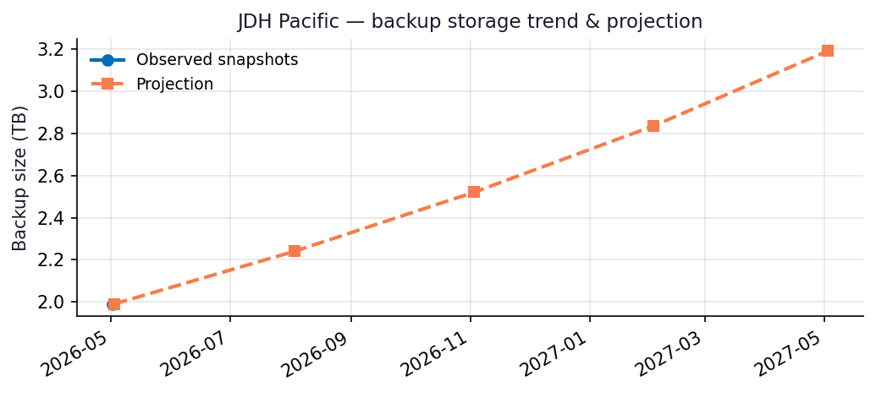
Recommendations
- Repository JDH_O365 is 67% full (1.00 TB free of 3.00 TB capacity).
- Capacity flag: Repository will hit ~90% utilization within 9 months at the current trend — begin capacity planning now.
- Coverage gap: Only 29/218 users have OneDrive backups. Confirm whether the remainder are intentionally excluded (licensing, role-based scope) or need to be added.
- Run this report monthly. The projection accuracy improves with each snapshot — after 3 snapshots the linear-regression fit replaces the industry-default growth assumption.

Appendix: Methodology & Data Sources
Data sources
- Veeam Backup for Microsoft 365 REST API at https://10.7.9.227:4443/v8 (OAuth2 password grant; self-signed TLS).
- Endpoints used: /Organizations, /Organizations/{id}/usedRepositories, /Organizations/{id}/users, /Organizations/{id}/users/{uid}/onedrives, /BackupRepositories, /Jobs, /RestorePoints?backupTimeFrom=...
Per-module attribution caveat
REST does not expose per-mailbox or per-OneDrive backup byte counts on this build. Per-module estimates reweight the total used storage by the share of restore points (over the trailing 90 days) that included each service. Treat the numbers as informed estimates, not invoiced figures. For ground-truth per-user/per-team sizes use the VB365 PowerShell module Get-VBOEntityData.
Trend projection
- With <2 monthly snapshots: project at 4%/month compound.
- With ≥2 snapshots: linear regression on log(bytes) over time.

